**Appendix 2: Furniture Heights Form**

Please complete all sections in the form and return to the RUH Occupational Therapy department via the details at the end of the form:

Patient Details:

Name:_____________________________________________ DOB:____________________

Address:_______________________________________________________________________________________________________________________________________________

**Chair -** Please measure the height from the lowest point of the compressed cushion to the floor.



**    **

Height (a) inches

Is this an Armchair or sofa? (please circle)

Is your chair a recliner? Yes /No

Please circle the leg type which is most similar to your chair/sofa

**Bed -** Measure the height from the lowest point of the compressed mattress to the floor.

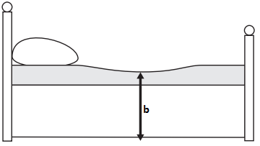

    

Height (b) inches

Is your bed a **single, double, king size**? Please circle

Please circle the leg type which is most similar to the legs of your bed.

**Toilet** - Measure from the seat to the floor with the lid raised.

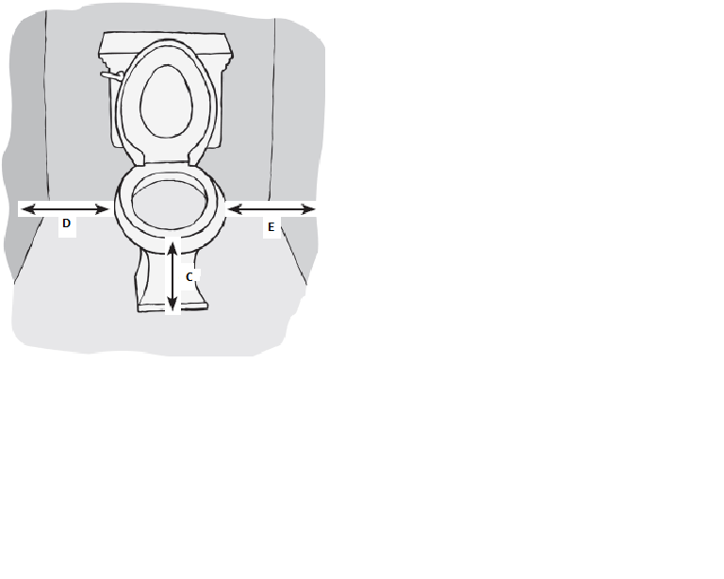

* How many toilets do you have? ______. Please measure each one.
* Upstairs toilet height ______ inches.
* Downstairs toilet height ______ inches.

How many toilets do you have? ­­­­ ­­­­­­

Please measure each one

|  |  |  |  |
| --- | --- | --- | --- |
| **Upstairs toilet** | | **Downstairs toilet** | |
| Height C |  | Height C |  |
| Width D |  | Width D |  |
| Width E |  | Width E |  |

**How to measure your leg length**

* Furniture should ideally be at least the height of your lower leg measurement.
* We therefore ask you to **measure the length of your lower leg** to guide which furniture you should ideally use initially after your operation**.** 
  + Wear flat, comfortable shoes.
  + Please sit on a firm chair with your feet flat on the floor.
  + Ask a friend or family member to measure from the crease in the **back of your knee to the floor at your heel**, in a straight vertical line, using a tape measure. (As shown in the photograph).

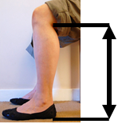

* Leg Length ______________________

Please return via postal address or scan and email:

Orthopaedic Occupational Therapy department

Brownsword Therapies Centre

Royal United Hospital

Bath

BA1

Email: [ruh-tr.furnitureheightforms@nhs.net](mailto:ruh-tr.furnitureheightforms@nhs.net)