Requesting an Add On in Millennium

- Does the request meet the relevant criteria:
http://www.ruh.nhs.uk/pathology/
requesting/additional_requests.asp

- Log into Powerchart & select the required patient

- Click on in the left menu bar

- Click on the Accession Number 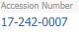next to the sample you wish to add a test on to

- The requests screen will appear

- Search for Add On (Blood Sciences) in the search bar and select

- The Order Form will appear

- Right click and paste in the first field to input the accession number.

- Complete the rest of the mandatory fields as required

e.g.

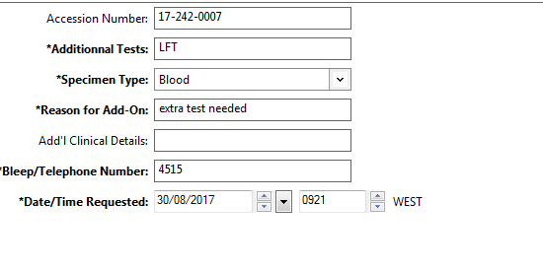

- Click Sign

- The add on will show in the requests/meds/careplans tab with a status of collected

- The lab staff will then receive this request and decide whether it should be accepted or rejected.

- The lab will message the requestor if an Add on test request is rejected.

- The results of an accepted Add on Test will appear in with the other results for the same sample.

