What is it? A service which emails you newly published documents based on your interests.
Why use it? To keep up-to-date with the latest high-level evidence in your field.
An NHS OpenAthens account will help you to make the most of the service, enabling direct access to full text documents where appropriate. You can register at https://openathens.nice.org.uk

Name |  | Title
Job Title |  | Department
Work Address
Email |  | Telephone

Condition / Risk Factors (eg stroke, diabetes, dementia) |  | Professional Interests  (eg patient safety, service design, leadership)
Age Groups  (please click to select) | Neonates  Children & Adolescents  Adults  Elderly | Settings  (eg surgery, inpatient ward, ED, community)

KnowledgeShare is designed to facilitate collaboration and sharing of knowledge within the NHS. May we make your contact details and interests visible to others?

Yes, all members Only members at my organisation Only Library Staff

Read the full KnowledgeShare privacy policy online at:
www.knowledgeshare.nhs.uk/index.php?PageID=help_privacy

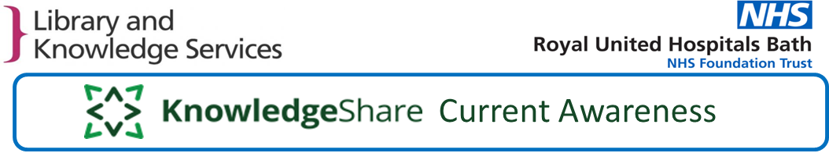
I would like to sign up for free KnowledgeShare updates sent to my email address.
I have read the KnowledgeShare privacy policy.

Dated to confirm consent

