Suspected Psoriatic Arthritis Referral Form
All referrals to the service are received via the Electronic Referral Service (eRS) – “Rheumatology” and mark referral “Suspected Psoriatic Arthritis”
Please select the urgency of the referral
Routine □ | Urgent □

PATIENT NAME, ADDRESS AND TELEPHONE NO. | DATE OF BIRTH | NHS NO. | CURRENT DIAGNOSES

The hallmark of PsA is joint, digit, entheses and tendon swelling associated with pain and stiffness.
It can causes axial inflammation resulting in inflammatory back pain.
30% of patients with psoriasis develop psoriatic arthritis.

Refer the following patients with suspected psoriatic arthritis (please tick) | PEST tool:
- Psoriasis or family history of psoriasis with history suggesting inflammatory arthritis  - Stiffness in any joint lasting >30 minutes in the morning □  - Painful and swollen joint □  - Dactylitis (Sausage finger/toe) □  - Inflammatory spinal pain □  - Psoriasis or family history of psoriasis presenting with enthesitis eg plantar fasciitis, tennis elbow or insertional Achilles pain □  - Positive PEST 3/5 (Screening of psoriasis patients using PEST tool) □ | 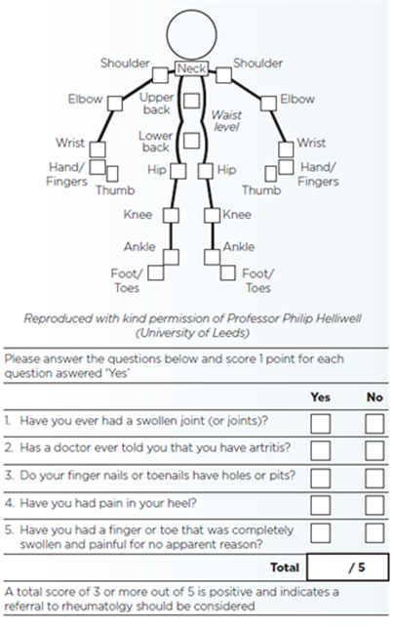

Please give details of the following aspects:
Duration of symptoms:

Pattern of joint involvement/spinal symptoms:

Presence/duration of early morning stiffness:

Psoriasis/FH of psoriasis:

Presence of nail changes:

Systemic symptoms eg weight loss, fever:

Examination findings:

Relevant family history:

Suggested investigations prior to referral: FBC, PV, CRP, U&E, creat, LFT, urate, RF, Xray affected joint (where possible). Please don’t delay referral if bloods are normal; CRP can be normal in psoriatic arthritis.

REFERRING GP’s NAME | SURGERY DETAILS | DATE OF REFERRAL
GMC registration number

