Royal United Hospital
Preceptorship Portfolio

Name | Click or tap here to enter text.
Ward/Unit/Department | Click or tap here to enter text.
Programme start date | Click or tap to enter a date.
Contents
Preceptorship 2
Who will you be with on the Preceptorship Programme? 3
Preceptorship Completion checklist 4
Charter between preceptor and Preceptee 5
Initial Meeting Template 6
Interim meeting template 8
Final sign-off meeting 10
Welcome to your Preceptorship 12
Preceptee Profile 12
SLOT analysis 13
Personal Development Plan (PDP) 14
Your journey so far reflection 15
Together for Improvement 16
Plan, Do, Study, Act Template 17
Communication and Inclusivity 18
Communication reflection 19
Human Factors and Simulation 20
Who am I now 21
Your Preceptorship journey reflection 22
Preceptor eLearning 23

Useful contacts:
Preceptorship: ruh-tr.preceptorship@nhs.net
Who | Email | Telephone
Careers Team | ruh-tr.careersengage@nhs.net
Freedom to Speak Up | ruh-tr.freedomtospeakup@nhs.net
Health & Well-being | ruh-tr.hwbconversations@nhs.net | 01225 824571
Improving Together | ruh-tr.ruhodprogramme@nhs.net
Inclusion Team | ruh-tr.EqualityandDiversity@nhs.net
Learning Disability & Autism | ruh-tr.learningdisabilities@nhs.net | 01225 824246
Learning support | ruh-tr.eLearningsupport@nhs.net | 01225 825902
Library | ruh-tr.library@nhs.net | 01225 824897
Palliative care | racheldavis1@nhs.net | 01225 825567
Patient Advice and Liaison Service | ruh-tr.pals@nhs.net | 01225 825656

Preceptorship

The preceptorship programme is designed to jumpstart a continuous journey of self-reflection and professional development that promotes accountability and safe practice. Our programme is aimed to support you in reflecting, learning and developing over the next 12 months. By the end of the programme, you will be more confident in;
- Providing safe, effective and person-centered healthcare
- Working effectively with colleagues and other multiprofessionals
- Facilitating learning in the workplace
- Using evidence to inform practice and improve services

The programme is not a revisit of your training but a means to maximize your professional development for the benefit of patients, the team/department, and yourself. Upon completion of the programme requirements, a certificate for 30 hours of face-to-face CPD time will be issued.
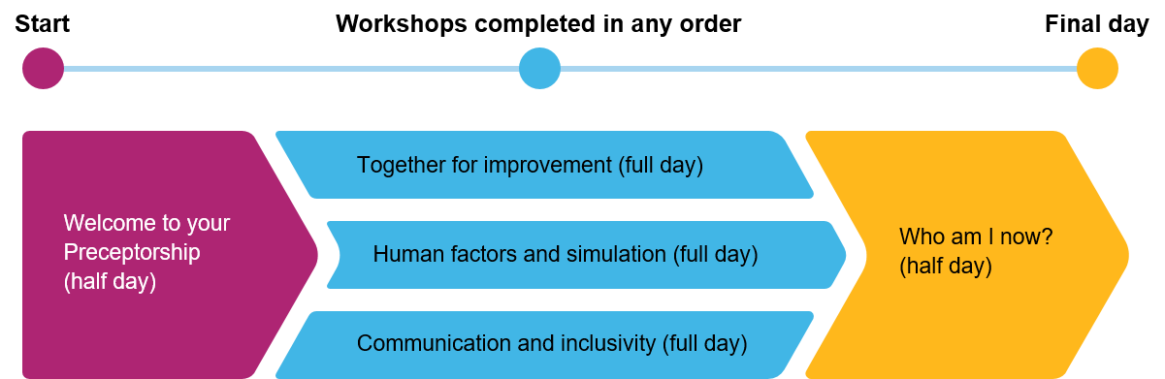
The programme consists of two half-days and three full facilitated learning days, which commence after completing your RUH induction. The three full days of the programme can be completed after the Welcome workshop, in any order, before attending the final "Who am I now" day. This flexibility ensures that you have control over the duration of your programme, although most staff aim to complete within 12 months.

This portfolio will be used as a resource to support your learning. Each section contains information and resources needed for the the workshops.
You will be supported by the Preceptorship team for the first 12 months of your registration, no matter how quickly you complete the workshops. You will also be supported by your manager, team and a nominated Preceptor in your workplace. Preceptors can change if you move to a different department or if you decide you would prefer someone else. They will act as your guide, mentor and coach at work.

Who will you be with on the Preceptorship Programme?

Throughout your Preceptorship journey, you will have the opportunity to collaborate with a diverse group of registered practitioners. These interactions will occur both within your workplace and during workshops. We believe that this arrangement will provide you with invaluable insights into various professions and foster an environment of interprofessional collaboration.
As part of the program, we encourage engagement with staff from professional bodies, including the Nursing and Midwifery Council (NMC), the Health and Care Professions Council (HCPC), and the General Pharmaceutical Council (GPhC). The range of professions represented in Preceptorship comprise of:
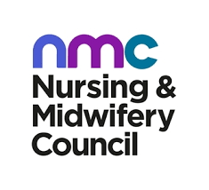
• Dietitians
• Health Care Scientists
• Midwives
• Nurse Associates
• Nurses
• Occupational Therapists
• Operating Department Practitioners
• Orthoptists
• Pharmacists
• Physiotherapists
• Podiatrists
• Prosthetics
• Radiography
• Speech and Language Therapists
Additionally, in the Human Factors workshop, you may find yourself learning alongside doctors who are participating in the programme.
We are confident that this diverse and inclusive learning environment will not only enrich your understanding of various healthcare professions but also empower you to forge meaningful and productive partnerships throughout your Preceptorship journey. We look forward to witnessing the professional growth and development that will arise from these collaborative experiences.

Preceptorship Completion checklist

Use this checklist over your Preceptorship Programme to document when you have completed each of the programme requirements. If the requirements are part of a workshop, you will be given time during that workshop to complete the tasks.
☐ Signed Preceptee Preceptor charter
☐ Completed intial meeting Date:Click or tap to enter a date.
☐ Completed interim meeting Date:Click or tap to enter a date.
☐ Completed final meeting Date:Click or tap to enter a date.
☐ Attendance at the Welcome to your Preceptorship Workshop
….☐ Completed Preceptee Profile
….☐ Completed SLOT analysis
….☐ Completed SMART Personal Development Plan
….☐ Completed reflection during session
☐ Attendance at Communication and Inclusivity Workshop
….☐ Completed reflection during session
☐ Attendance at Together for Improvement Workshop
….☐ Completed Leadership and Personality Style questionnaire
….☐ Completed PDSA cycle
….☐ Contributed Quality Improvement in workplace
☐ Attendance at Human Factors & Simulations Workshop
☐ Attendance at Who am I now Workshop
….☐ Completed reflection during session
….☐ Completed the eLearning Preceptor eCompendium programme
Once you have completed all the requirements you will need to fill in the completion checklist on LearnTogether within the Preceptorship Programme. The checklist is unlocked after completing all workshops. Finishing this checklist is the last step in finishing the Preceptorship Programme and will give you your 30 hour CPD certificate.

Charter between preceptor and Preceptee

When you have selected your Preceptor, sign this charter with them! If you have any trouble choosing a Preceptor or have some questions, ask or email the team.
Your Preceptor should fulfil these requirements:
- 12 months registered experience in your clinical area
- Up to date with mandatory training
- Clinically competent and up date with skills in their area
- Ideally someone you get along with and is eager to volunteer and support

Preceptee
I understand that my responsibilities as a newly registered practitioner and preceptee include:
- Completing the organisation induction, local induction, statutory training and mandatory training
- Attending study days and all required learning and development to complete my preceptorship
- Observing and adhering to organisation values
- Participating fully in the preceptorship programme by preparing for and attending meetings as scheduled with my preceptor
- Working collaboratively with my preceptor to share my reflections and identify learning and development needs
- Seeking feedback from others to inform my progress
- Owning my learning and development plan.
Name:  Click or tap here to enter text. | Signature:  Click or tap here to enter text. | Date:  Click or tap to enter a date.
Preceptor
I understand that my responsibilities as a preceptor include:
- Providing support and guidance to the newly registered practitioner
- Acting as a role model and professional friend
- Facilitating introductions and promoting good working relationships
- Participating in all preceptorship activities including attending required training, and facilitating and documenting regular scheduled meetings
- Providing timely and appropriate feedback to the preceptee
- Liaising with manager about the preceptee’s progress as appropriate
- Advising on learning and development needs, facilitating a supportive learning environment and signposting learning resources
- Completing and continuing my development as a preceptor.
Name:  Click or tap here to enter text. | Signature:  Click or tap here to enter text. | Date:  Click or tap to enter a date.

Initial Meeting Template

Name of preceptee | Click or tap here to enter text.
Name of preceptor | Click or tap here to enter text.
Work area | Click or tap here to enter text.
Date of meeting | Click or tap to enter a date.

Icebreaker questions
Tell me a little about yourself. What do you enjoy doing? What are you looking forward to about your new role? What do you think is going to be challenging? How much do you know about preceptorship?

Click or tap here to enter text.

Expectations
What are your expectations of your new role? What development do you expect? What level of support do you expect from your preceptor?

Click or tap here to enter text.

New starter checklist  Organisation induction  Clinical induction  Local induction | Click or tap here to enter text.
Comments/notes:

Click or tap here to enter text.

Actions:

Click or tap here to enter text.

Next meeting: | Click or tap to enter a date.
Preceptee signature | Click or tap here to enter text.
Preceptor signature | Click or tap here to enter text.

Interim meeting template

Name of preceptee | Click or tap here to enter text.
Name of preceptor | Click or tap here to enter text.
Work area | Click or tap here to enter text.
Date of meeting | Click or tap to enter a date.

Reflection and discussion
What has gone well? What challenges have you met? How have you overcome them? Consider use of reflection templates* and the sharing of observations (it is recommended that five reflections are completed during the preceptorship period).

Click or tap here to enter text.

Review of development
What development/study days have you had? How have you found these? What has gone well? What have you found difficult? Are there areas in which you need more development or experience? Progression points?

Click or tap here to enter text.

Review of Personal Development Plan
Review PDP set during previous meeting. Assess achievement against objectives and, where appropriate, set further objectives.

Click or tap here to enter text.

Comments/notes:

Click or tap here to enter text.

Actions agreed:

Click or tap here to enter text.

Next meeting: | Click or tap to enter a date.
Preceptee signature | Click or tap here to enter text.
Preceptor signature | Click or tap here to enter text.

Final sign-off meeting

Name of preceptee | Click or tap here to enter text.
Name of preceptor | Click or tap here to enter text.
Work area | Click or tap here to enter text.
Date of meeting | Click or tap to enter a date.

Reflection and discussion
What has gone well? What challenges have you met? How have you overcome them?

Click or tap here to enter text.

Review of development
What development/study days have you had? How have you found these? What has gone well? What have you found difficult? Are there areas in which you need more development or experience? Progression points?

Click or tap here to enter text.

Review of Personal Development Plan
Review PDP set during previous meeting. Assess achievement against objectives and, where appropriate, set further objectives.

Click or tap here to enter text.

What career development will I now pursue?
What study days or development opportunities can I now peruse with my experience? What link roles can I progress? What do I want to do next and how?

Click or tap here to enter text.

Comments/notes:

Click or tap here to enter text.

Preceptee signature | Click or tap here to enter text.
Preceptor signature | Click or tap here to enter text.
Whilst meetings are a requirement, completing the final sign-off meeting does not mean you have completed the Preceptorship Programme.
Pease check the Preceptorship Programme completion checklist on page 4.

Welcome to your Preceptorship

Today focuses on who you are at the beginning of the programme so that you can start to plan your own programme around your needs. This is to support you;

- To understand how preceptorship can support my professional development
- To understand my role within the wider integrated care system
- To explore the support that is available to manage stress and develop resilience
- To align my Personal Development Plans with the trust values and 4 pillars
- To have created an informal support network of peers
- To be able to discuss how reflection can help to create a greater sense of self-awareness

Preceptee Profile

A bit about me:
Click or tap here to enter text.
My clinical experience to date:
Click or tap here to enter text.
My Strengths:  Click or tap here to enter text. | Areas I want to develop:  Click or tap here to enter text.
My Learning Style and Learning Needs:  Click or tap here to enter text. | My Well-being Techniques:  Click or tap here to enter text.

SLOT analysis

A SLOT analysis is a simple tool to evaluate the preceptee’s current stage of knowledge, skill and experience and to assess development needs along with opportunities and barriers.
Strengths  What do you do well? What knowledge, skill and experience do you have? Consider attitudinal strengths.  Click or tap here to enter text. | Learning Needs  Are there any gaps in your learning or experience? Do you need more experience in anything? Consider personal, clinical and professional development.  Click or tap here to enter text.
Opportunities  What development opportunities are available? Consider shadowing, training, working with others, and research.  Click or tap here to enter text. | Threats  What are the barriers? Consider time, workload pressures, personal commitments and energy levels.  Click or tap here to enter text.

Personal Development Plan (PDP)

The individual learning plan records development needs and agreed objectives. Objectives should be SMART (specific, measurable, achievable, realistic/relevant and time bound).
Personal Development Plan
What are the areas I need to work on? | What action will I take now? | When will I review progress again?
Click or tap here to enter text. | Click or tap here to enter text. | Click or tap to enter a date.
Click or tap here to enter text. | Click or tap here to enter text. | Click or tap to enter a date.
Click or tap here to enter text. | Click or tap here to enter text. | Click or tap to enter a date.

Learning needs should come from the SLOT analysis and should identify specific needs.
There should be no more than three objectives for each CPD, in order for it to be realistic.

Your journey so far reflection

This reflection template is based on Rolfe et al (2001). It has been designed as a simple way of learning from experience, evaluating the experience and identifying further action. Write a reflection on your time in the trust so far.
What?
What happened? What did I do? How did I feel? What was good or bad? How did others respond? What were the consequences?

Click or tap here to enter text.
So what?
So what did I learn from this? What did I base my actions on? What could I have done differently? What is my new understanding of the situation?

Click or tap here to enter text.

Now what?
What do I need to do differently? Are there things I need to learn or consider? What do I need to do next time?

Click or tap here to enter text.

Together for Improvement

This full day focuses on understand behaviours and how this can influence our work cultures. As well as seeking out ways to develop and improve quality of practice and care. The day will be a mixture of group activities and sessions. This is to support you;

- To be able to work effectively as part of a team to achieve value-added patient, staff, and organisational outcomes
- To have an awareness of team dynamics
- To understand how values and behaviours can influence work cultures
- To have an awareness of how to apply Quality Improvement Methodologies
- To have awareness of how create a supportive learning culture for peers and students
- To seek out ways to develop and improve quality of practice and care
Open text box for your own questions or notes.
Click or tap here to enter text.

16 Personalities result | Click or tap here to enter text.

Plan, Do, Study, Act Template

What are we trying to accomplish?

Click or tap here to enter text.

How will we know that a change is an improvement?

Click or tap here to enter text.

What change can we make that will result in an improvement?

Click or tap here to enter text.

- Plan  Click or tap here to enter text. | - Do  Click or tap here to enter text.
- Study  Click or tap here to enter text. | - Act  Click or tap here to enter text.

Communication and Inclusivity

Focusing on communication this full day explores how culture and experience can impact on our individuals' values, beliefs, behaviours and decision making. The day will be a mixture of group activities and sessions. This is to support you;

- To formulate and utilise effective communication strategies and styles
- To discuss resilience and coping strategies that positively affect wellbeing
- To be aware of how culture and experience can impact individuals' values, beliefs, behaviours, and decision making
- To have an increased awareness of how Inclusion, Diversity and Bias can influence our workplaces and communication.
Open text box for your own questions or notes.

Click or tap here to enter text.

Communication reflection

Write a reflection on when you have witness/observed a good or bad example of communication, or a time you have been involved with good or bad communication.

What?
What happened? What did I do? How did I feel? What was good or bad? How did others respond? What were the consequences?

Click or tap here to enter text.

So what?
So what did I learn from this? What did I base my actions on? What could I have done differently? What is my new understanding of the situation?

Click or tap here to enter text.

Now what?
What do I need to do differently? Are there things I need to learn or consider? What do I need to do next time?

Click or tap here to enter text.

Human Factors and Simulation

This full day supports you to gain a deeper understanding of technology, systems and processes, safety culture and human error to enhance care and patient safety. The day will be a mixture of simulations and activities so that you can, experience life-like scenarios that are followed by opportunities for learners to reflect within a structured and facilitated debrief. This is to support you;

- To be able to work with colleagues and other multidisciplinary professionals to provide a cohesive approach to patient care
- To gain a deeper understanding of techniques, systems and processes, safety culture and human error to enhance care and safety
- To experience scenarios that are followed by opportunities for learners to reflect within a structured and facilitated debrief
- To understand the components of effective team working
Open text box for your own questions or notes.

Click or tap here to enter text.

Who am I now

This final half day focuses on who you are now at the end of the programme and reflect to see how you have developed and explores further training should you now wish to support others as a preceptor. This is to support you;

- To be able to engage with ongoing professional development, though defining further goals and creating opportunities
- To have awareness of how create a supportive learning culture for peers
- To have an awareness of the role of the preceptor and how to become one
Open text box for your own questions or notes.

Click or tap here to enter text.

Your Preceptorship journey reflection

Write a reflection on your Preceptorship journey.
What?
What happened? What did I do? How did I feel? What was good or bad? How did others respond? What were the consequences?

Click or tap here to enter text.

So what?
So what did I learn from this? What did I base my actions on? What could I have done differently? What is my new understanding of the situation?

Click or tap here to enter text.

Now what?
What do I need to do differently? Are there things I need to learn or consider? What do I need to do next time?

Click or tap here to enter text.

Preceptor eLearning

The aim of the Preceptor eCompendium is to recognise the needs of the preceptor, too, and to provide them with the guidance, support, resources and practical tools that they need for this role. It aims to help them reflect on their own experiences of this transition into the workforce, and to optimise their knowledge and skills to best position themselves to support others. It also supports the preceptor to develop valuable skills that will help them in other supporting roles that they will find themselves taking on during their current or future roles.
This programme is made up of 5 learning sessions, consisting of:
Session1: The Preceptor Role
Session 2: Leading and coaching Preceptees
Session 3: Identifying/agreeing the Preceptee’s learning/support needs
Session 4: The health and well-being of the Preceptor and Preceptee
Session 5: Reflecting on your experience as a Preceptor
Find the eLearning sessions as part of Preceptorship Day 5: ‘Who am I now’

Completion will be automatically recorded on LearnTogether

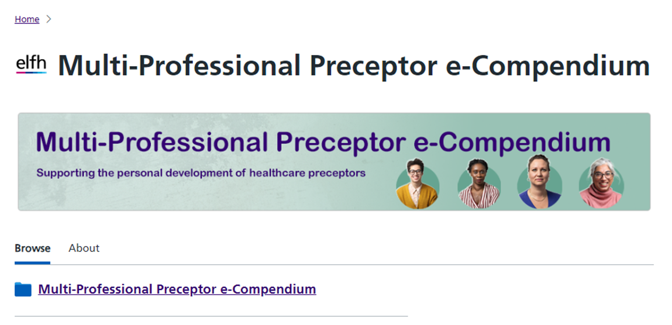

https://www.e-lfh.org.uk/programmes/multi-professional-preceptor-e-compendium/

