SUSPECTED LOWER GASTRO-INTESTINAL CANCER REFERRAL FORM
Referrals to be sent via e-RS or e-mail RUH-TR.CancerReferrals@nhs.net
Referrer Details | Patient Details
Name: |  | DoB:
Address: | Address: | Gender:
 |  | Hospital No.:
 |  | NHS No:
Tel No: | Home No.: | Please check tel. nos.
 | Mobile No.:
Email: | Carer requirements (has dementia or learning difficulties)? | Does the patient have the capacity to consent? Yes ☐ No ☐
Decision to Refer Date: | Translator Required: Yes ☐ No ☐ Language:  Communication needs: | Transport required: Yes ☐ No ☐  Mobility:

 | YES | NO
The patient has been made aware that this is a Suspected Cancer Referral
The patient has received the two week wait leaflet
The patient has been informed that they may be contacted by secondary care to undergo further tests directly
The patient is available to attend appointments/test in the next 14 days-
If patient is not available for the next 2 weeks, consider reinforcing potential urgency/safetynetting, and only referring when able and willing to accept an appointment.
If your patient is found to have cancer, are there pre-existing psychological factors to be aware of when discussing diagnosis/ further management?
Please confirm you have completed the frailty scale below (needed to assess appropriate onward management including faster, ‘straight to test’ options).
PATIENT ENGAGEMENT

Clinical details
Please include symptoms and examination findings or attach referral letter.

SYMPTOMS & CLINICAL EXAMINATIONS
As per cancer alliance and ICB endorsement, and in line with new national guidance to GPs, all patients should have FBC/ferritin and undertake a FIT test with results available prior to referral on this pathway, unless presenting with anal mass/ulceration or abdominal/rectal mass; (or with high risk iron deficiency anaemia)

☐ qFIT positive >10 Result: __________ µgHb/g Date:
☐ Patient unable to undertake qFIT (pls complete Frailty below and outline reason in Clinical Details section)
Please only access this 2ww pathway for patients who also fulfil one/ more of the following referral criteria:

☐ | Anal Mass OR ulceration (no qFIT requirement)
☐ | Rectal OR abdominal mass (no qFIT requirement)
☐ | Unexplained rectal bleeding (with qFIT result)
☐ | Unexplained Abdominal pain, weight loss, change in bowel habit or non-iron deficient anaemia WITH documented qFIT +ve result
☐ | Unexplained iron deficiency anaemia (please consider performing qFIT for pre-menopausal women)
Pathway for Colorectal 2ww referral

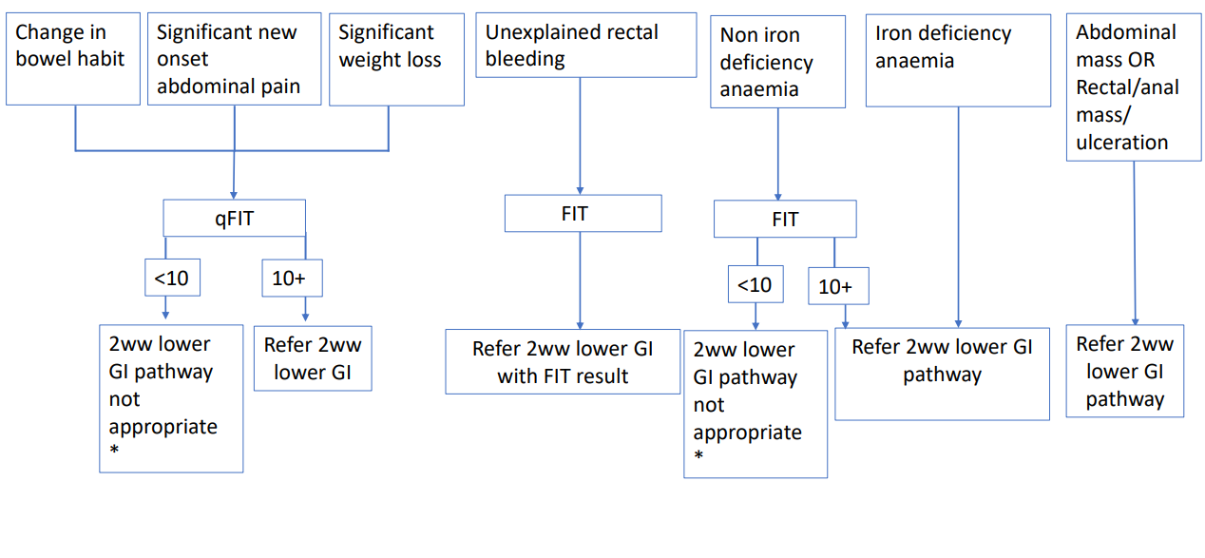
*GP to consider further investigations as colorectal cancer is unlikely to be the cause of symptoms.

If patients remain symptomatic secondary care referral options include urgent gastroenterology or routine colorectal pathways or consultant discussion via Cinapsis.

If the patient does not fulfil referral criteria OR is qFIT -ve, but a high clinical suspicion of colorectal cancer remains, please consider repeating qFIT at 4-6 week (patients with two negative FIT test results have a colorectal cancer risk of <0.04%) OR seek advice of a consultant colorectal surgeon via Cinapsis.

Blood Results: (Within last 6 weeks)
FBC
UE
LFT
CRP |  |  | ESR
TFTs |  |  | INR
Bone
Iron
Vitamins
Lipids
Random Glucose |  |  | Fasting Chol.
Fasting Glucose |  |  | HbA1c

PLEASE TICK AS APPROPRIATE- THIS MUST BE COMPLETED
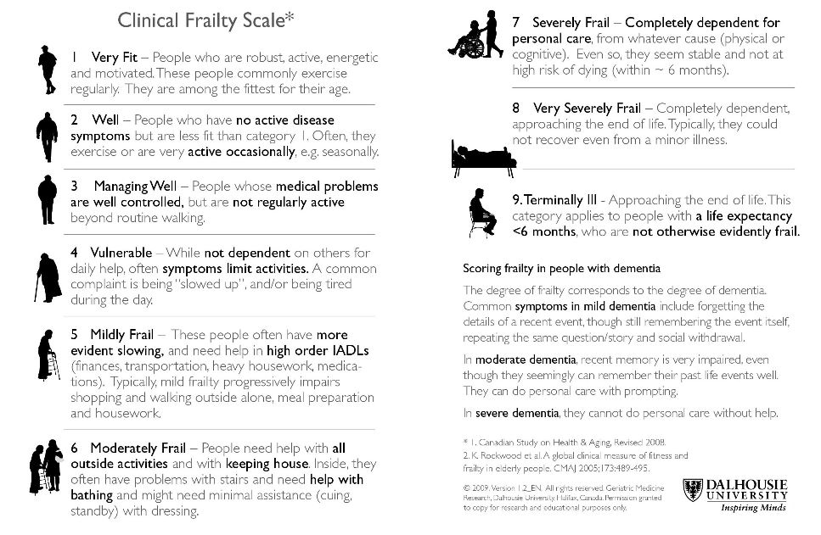

Medication:
Allergies:

Additional Clinic Information

Has a Rectal Examination been completed?
Past History of Cancer
Family History
Smoking Status
Alcohol Intake
Is the patient on any Anti-coagulants?
Is the patient on any Anti-platelet therapy?
Is the patient diabetic?
Weight
BMI

